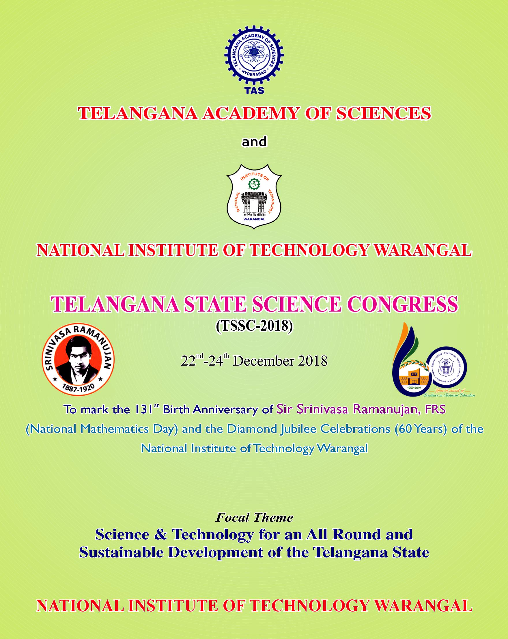

***Jointly Organize the Prestigious***

*(131 is the biggest single digit prime-numbered three digit prime and*

*60 is the lowest two digit number with the highest number of factors)*

***Venue***

**Telangana State Science Congress (TSSC-2018)**

Andhra Pradesh Academy of Sciences (APAS) was established in the undivided state of Andhra Pradesh in the year, 1963, for promoting scientific knowledge including practical application to problems of the State welfare. APAS has been rechristened as "Telangana Academy of Sciences (TAS)" after the formation of the Telangana State.

TAS has been actively involved in disseminating scientific knowledge to the society through its activities by organizing meets, discussions, seminars, conferences and symposia and bringing out books and publications of popular science. The Academy takes forward scientific creative activity through education, research and discovery by identification and nurturing of scientific talent among the young.

As part of its major flagship activities, the TAS is holding first ever Telangana State Science Congress (TSSC-2018) during 22nd-24th December, 2018 in association with the National Institute of Technology (NIT) Warangal as part of the latter's Diamond Jubilee Celebrations. The event also marks the 131st Birth Anniversary of the Indian Mathematical prodigal genius, Sir Srinivasa Ramanujan (22nd December, 1887), Which is observed, every year, as **"National** **Mathematics Day".** This event is mainly aimed at promotinginteraction among the scientific community across various disciplines at National and International level, besides popularizing science among the teachers and students.

The TSSC-2018 will have scientific sessions on SEVEN major themes on Science and Technology besides some special sessions.

**About the Telangana Academy of Sciences (TAS)**

Telangana Academy of Sciences has been working relentlessly to promote scientific temper in Telangana State. It has been recognizing eminent scientists / Professors and electing them to the fellowship of the Academy. TAS also promotes children science activities, encourages young scientists towards inventions, investigations and research in pursuit of excellence in the fields of Science and Technology. Its activities include organizing endowment lectures, seminars, symposia, popular exhibitions and programs on overall perception of science and society.

For the last 55 years, the activities of the Academy have immensely helped in sharing the academic scholarship among its Fellows and Associate Fellows, in particular and the scientific community, in general. They have also catalyzed popularization of science and inculcation of scientific temper among children and general public. The Academy, in a bid to reach the wider community and to extend its activities, has established Five Regional Centers at Nizamabad, Karimnagar, Hyderabad, Nalgonda and Warangal covering all the Districts of Telangana State.

**About the Focal Theme**

The Focal theme for the Telangana State Science Congress-2018 is

***"Science & Technology for an All Round and Sustainable***

***Development of the Telangana State".*** The State of Telangana is theyoungest and the 29th State in India. It has been formed on 2nd June, 2014 through the AP Reorganization Act. Being an infantile federal state with rich cultural heritage and abundant natural and human resources but low industrial and literacy, the State of Telangana is poised to leap into an all round and sustainable development. Sustainable development addresses the socio-economic development catalysed by scientific, technological and industrial advances. The proactive cooperation and positive support of the scientific community would augment and empower the Government for a sustainable development of the Telangana State. The development of the State is intertwined with the advancements in Science and Technology in different fields, namely, cleaner & fuel efficient technogies, de-fluoridation of drinking water, solar energy harnessing housing technology, entrepreneurship development, human health, water resources, information technology, biotechnology, sustainable human resource management, etc. The TSSC-2018 will identify the key areas in the activities of planning for an all round and sustainable development of the Telangana State.

**About the National Institute of Technology Warangal (NITW)**



The National Institute of Technology Warangal (NITW), formerly known as the Regional Engineering College Warangal, is the first among the chain of 31 NITs crowned as Institutes of National Importance. It was established by an Act of Parliament. The country's first Prime Minister, Pandit Jawaharlal Nehru laid the foundation stone on 10th October, 1959 for this Institute. Thus, 10th October, 2018 marks the commencement of the **Diamond Jubilee Celebrations** of NITW.

The Institute presently offers 8 B.Tech Programmes in Engineering, 25 M.Tech Programmes and 7 other Postgraduate Programmes (M.Sc., M.Sc (Tech)., MCA and MBA) and PhD Programmes in all the thirteen Departments including Engineering, Sciences, Humanities, Management and Physical Education. The institute is well-known for its Research and Development, state of the art laboratories, Industrial consultancy, Continuing Education Programmes for teachers and industrial personnel.

The World Bank supports the Institute through Technical Education Quality Improvement Programme (TEQIP) and currently Phase III is in progress. The MHRD has recognized NITW as one of the six E&ICT Academies in the country. NITW also hosts scores of advanced short-term training courses conducted by International academicians under the MHRD's Global Initiative for Academic Network (GIAN) Programme.

The institute has about 600 foreign students from as many as 40 countries. It has strong academic and research collaborations with several leading foreign universities and through programs like HERITAGE, EUPHRATES, HORIZON-2020, etc. Students and faculty avail themselves of several short-term international exchange and mobility programs through these channels.

The Institute is recognized by the MHRD to run a Teaching Learning Centre (TLC) for Higher Education and is recognized as a National Resource Centre (NRC) in Mathematics under the Pandit Madan Mohan Malaviya National Mission on Teachers and Teaching (PMMMNMTT). The MHRD has also recognized NIT Warangal as a Mentoring Institute under its very proactive mission, the Rasthtriya Avishkar Abhyan (RAA) to mentor the school science education in the State of Telangana.

A year-long **Diamond Jubilee Celebrations (DJC)** are planned with the kick start of a grand Inaugural Function on 8th October with none other than the Honorable Vice President of India, Sri M. Venkaiah Naidu as the Chief Guest followed by a National Conference on **"Evolution of**

**World Class Technical Institutions - Issues & Concerns"** during 10th-

12th October, 2018.

**About the Warangal City**

Warangal is a historical city with rich cultural and diverse heritage. It was the capital city of the famous Kakatiya Kingdom during the 12th-14th Century AD. There are many intricately carved monuments built by the Kakatiyas in this region. The 1000 Pillar Temple, Warangal Fort, Ramappa Temple,etc.,bear testimony to the historic period. Warangal has been identified as a heritage city by the UNESCO. The biennial Medaram Fair, the most populous 3-day cultural fair, Laknavaram Lake, Pakhal Lake and Eturunagaram Reserve Forests are excellent tourist attractions and are just within 100 kms from the City. There are also many other scenic waterfalls nearby.

The city is well connected by road and rail network to the rest of the Country. Warangal Railway Station is 12 kms and Kazipet Railway Station is just 2 kms away from NIT campus. The nearest Airport is Rajiv Gandhi International Airport at Hyderabad, another historic city and capital of Telangana State, at a distance of about 170 kms from NIT campus. Warangal City is adapted as one of the Smart Cities by the Government of India and is destined to be a highly happening city in the very near days to come.

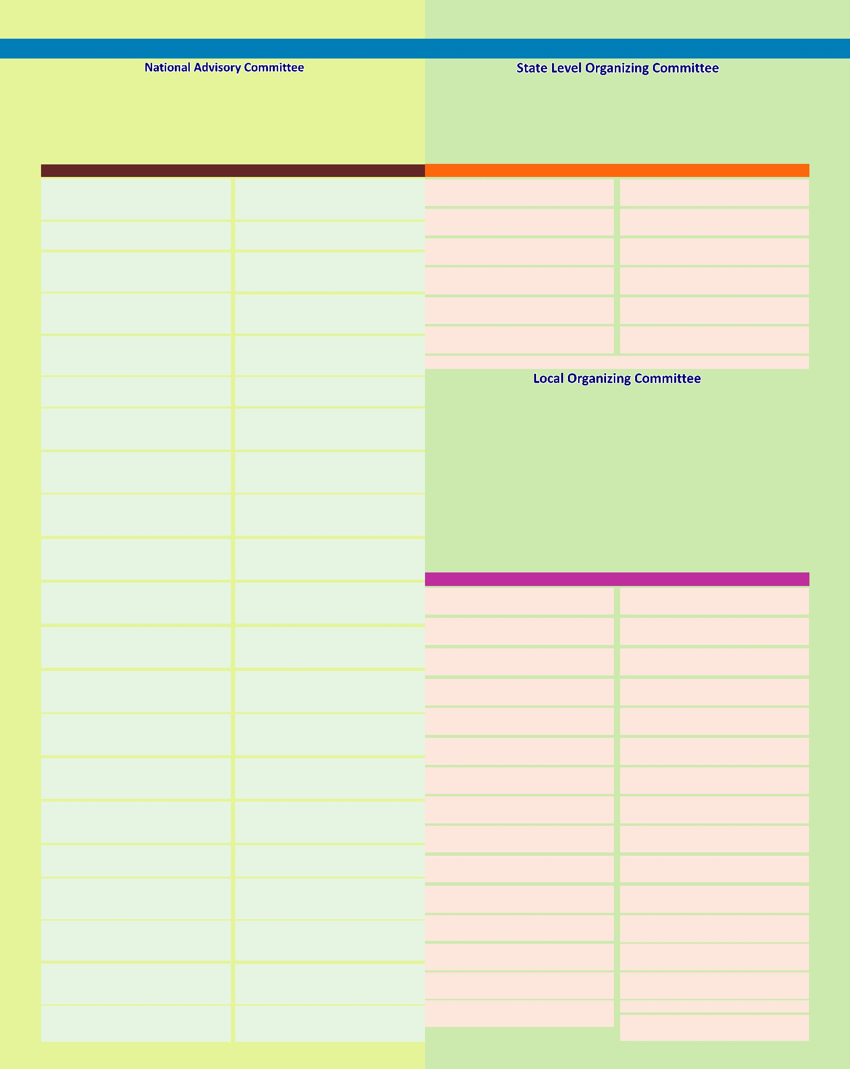**Telangana State Science Congress - 2018**

*Patrons*

|  |  |
| --- | --- |
| **Prof. K. Narasimha Reddy** | **Prof. N.V. Ramana Rao** |
| President | Director |
| Telangana Academy of Sciences, | National Institute of Technology Warangal |
| Hyderabad |  |
| *Members* | |
| Principal Secretary | Sri. Navin Mittal, I.A.S, |

*Chair Persons*

|  |  |
| --- | --- |
| **Dr. S. Chandrasekhar** | **Prof. N.V. Ramana Rao** |
| Hon. Secretary, TAS, Hyderabad | Director, NIT Warangal |
| *Organizing Secretaries* | |
| **Dr. Y. Purushotham** | **Prof. K. Laxma Reddy** |
| Hon. Treasurer, TAS, Hyderabad | Professor of Chemistry, NITW |
| *Members* |  |
| Prof. P. Venugopal Reddy | Prof. Ch. Sanjeeva Reddy |

Department of Higher Education Govt. of Telangana

Prof. T. Papi Reddy

Chairman, TSCHE, Hyderabad

Prof. P. Appa Rao

Vice-Chancellor,

University of Hyderabad, Hyderabad

Dr. U.B. Desai

Director, IIT,

Hyderabad

Prof. S. Ramachandram

Vice-Chancellor,

Osmania University, Hyderabad

Prof. A. Venugopal Reddy

Vice-Chancellor, JNTU, Hyderabad

Prof. R. Sayanna

Vice-Chancellor,

Kakatiya University, Warangal

Prof. V. Praveen Rao

Vice-Chancellor,

Prof. Jaya Shanker Agri. Univ. Hyd.

Prof. Khaja Althaf Hussain

Vice-Chancellor,

MG. University, Nalgonda

Prof. B. Raja Ratnam

Vice-Chancellor,

Palamuru University, Mahabubnagar

Dr. A. Ashok, IAS,

I/c. Vice-Chancellor,

RGUKT, Basara

Prof. P. Sambaiah

Vice-Chancellor,

Telangana University, Nizamabad

Sri. T. Chiranjeevulu, IAS,

I/c. Vice-Chancellor,

Satavahana University Karimnagar

Prof. K. Seetharama Rao

Vice-Chancellor,

Dr. B.R. Ambedkar Open Uni., Hyd

Sri Sandeep Kumar Sultania

P.V. Narasimha Rao

Telangana Vet. Uni., Hyd

Sri. C. Parthasarathi, IAS,

I/c. Vice-Chancellor,

Sri KL Telangana Harti. Univ., Hyd.

Dr. Dinesh Kumar Likhi

CMD, MIDHANI, Hyderabad

Dr. B. Karunakar Reddy

Vice-Chancellor,

Kaloji N Rao Health Uni., Warangal

Dr. Ms. M. Lakshmi Kantham

Former Director,

IICT, Hyderabad

Dr. A.V. Rama Rao

Chairman AVRA Labs,

Hyderabad

Prof. E. Suresh Kumar

Vice-Chancellor,

EFLU, Hyderabad

Commissioner,

Collegiate Education, Govt. of Telangana

Prof. P. J. Narayanan

Director, IIIT, Hyderabad

Prof. D. Balasubramanian

Research Director,

LV Prasad Eye Institute , Hyd

Dr. Ch. Mohan Rao

Former President, TAS &

Former Director, CCMB, Hyd'bad

Dr. S. Chandrasekhar

Director, IICT,

Hyderabad

Dr. V. M. Tiwari

Director, NGRI, Hyderabad

Dr. Rakesh K Mishra

Director,

CCMB, Hyderabad

Dr. Tessy Thomas

Director General,

AERO, Bangalore

Dr. R. Hemalatha

Director,

NIN, Hyderabad

Dr. Santanu Chowdhury

Director,

NRSC,Hyderabad

Dr. G. Padmanabham

Director,

ARCI, Hyderabad

Dr. M.S.R. Prasad

Director,

DRDL, Hyderabad

Dr. Anil Kumar Singh

Director,

DLRL, Hyderabad

Dr. N.R. Muniratnam

Director General,

C-MET, Pune

Dr. M.B. Verma

Director,

AMD, Hyderabad

Dr Vikas Kumar

Director,

DMRL, Hyderabad

Dr. Sanjay Chaubey

CMD, ECIL, Hyderabad

Dr. Dinesh Srivatsava

Chief Executive,

NFC, Hyderabad

Dr. Sateesh Chandra Shenoi

Director,

INCOIS, Hyderabad

Prof. P. Ravi Kumar

Member Secretary,

TSCOST, Govt of Telangana

Dr. B. G. Sidharth

Director,

B.M. Birla Science Centre, Hyd'bad 

|  |  |  |
| --- | --- | --- |
| Vice President, TAS | Vice President, TAS |  |
| Prof. S. M. Reddy | Dr. Ch. Mohan Rao |  |
| Editor, Publications, TAS | E.C. Member (Ex. Officio) |  |
| Dr. G. Sundararajan | Dr. G. Parthasaradhy |  |
| E.C Member, TAS | E.C. Member, TAS |  |
| Prof. K. Janaradhan Reddy | Dr. G. Bhanuprakash Reddy |  |
| E.C. Member, TAS | E.C. Member, TAS |  |
| Prof. K.Jeevan Rao | Dr. G. Madhusudhan Reddy |  |
| E.C. Member, TAS | E.C. Member, TAS |  |
| Prof. G. Bagyanarayana | Prof. V. Chakravarthy |  |
| E.C. Member, TAS | E.C. Member, TAS |  |
| Prof. M. Vittal, Regional Coordinator, TAS, Adilabad & Karimnagar | |  |
| *Chairman* | *Vice Chairmen* |  |
| **Prof. K.V. Jayakumar** | **Prof. A. Ramachandraiah** |  |
| Dean, IRAA and | Member, Board of Governors, NITW |  |
| Coordinator, GIAN, NITW | **Prof. CSRK Prasad** |  |
|  | Organising Secretary, DJC, NITW |  |
| *Organising Secretaries* | *Joint Secretaries* |  |
| **Dr. Y. Purushotham** | **Prof. S. H. Sonawane,** Chem. Engg. NITW |  |
| Hon. Treasurer, TAS | **Prof. P. Rathish Kumar,** Civil Engg, NITW |  |
| **Prof. K. Laxma Reddy** | **Prof. L. Anjaneyulu,** ECE, NITW |  |
|  |  |

**Prof. N. Narasaiah,** MME, NITW

Professor of Chemistry, NITW

*Treasurer*

**Dr. R. Satish Babu**

Biotechnology, NITW

Members

|  |  |
| --- | --- |
| Prof. Y. Pydisetty | Prof. DVSS Siva Sarma |
| Dean, Academic, NITW | Dean, FW, NITW |
| Prof. P. Anand Raj | Prof. LRG Reddy |
| Dean, P & D, NITW | Dean, SW, NITW |
| Prof. G. Rajesh Kumar | Sri. S. Goverdhan Rao |
| Dean, R& C, NITW | Registrar, NITW |
| Prof. Ch. Sanjeeva Reddy | Prof. S. M. Reddy |
| Vice-President, TAS | Editor, Publications, TAS |
| Prof. M. Chandrasekhar | Prof. T. Somasekhar |
| Head, Civil & Chairman, Games | Head, EEE, NITW |
| Prof. P. Bangaru Babu | Prof. N. Bheema Rao |
| Head, MED, NITW | Head, ECE, NITW |
| Dr. Ms. C. Vanitha | Prof. A. Sarath Babu |
| Head, MME, NITW | Head, Chemical, NITW |
| Prof. R. B. V. Subramanyam | Dr. Onkara Perumal |
| Head, CSE, NITW | Head, Biotechnology, NITW |
| Prof. D. Srinivasacharya | Prof. KVG Reddy |
| Head, Mathematics, NITW | Head, Physics, NITW |
| Prof. Ms. P. V. Srilakshmi | Dr. M. Raja Viswanathan |
| Head, Chemistry, NITW | Head, H & SS, NITW |
| Dr. P. Ramalal | Prof. L. Krishnanand |
| Head, SOM, NITW | Coordinator, TEQIP, NITW |
| Prof. P. Madhusudhan Reddy | Prof. A. Venu Vinod |
| Head, Phy.Edn., NITW | Chief Warden, NITW |
| Prof. T. Kishore Kumar | Prof. D. M. Vinod Kumar |
| Head, CC, NITW | Chairman, Library, NITW |
| Prof. A. Neelakanteshwara Rao | Prof. N. Selvaraj |
| Chairman, EWC, NITW | Chairman, Hospital, NITW |
| Dr. S. Venkateswara Rao | Prof. B. V. Appa Rao, FTAS, NITW |
| I/c. Civil, PE Office, NITW | Ms. M. L. Madhavi |
| Prof. M. Komal Reddy, FTAS, SU | I/c. Asst. Secretary, TAS, Hyd |

Theme Sessions

Physical & Mathematical Sciences

Engineering & Technology

Chemical Sciences

Life Sciences & Agricultural Sciences

Medical, Health & Pharmaceutical Sciences

Earth, Ocean, Atmospheric & Environmental Sciences

Special Session on Interaction of Scientists with Students

**Telangana State Science Congress - 2018**

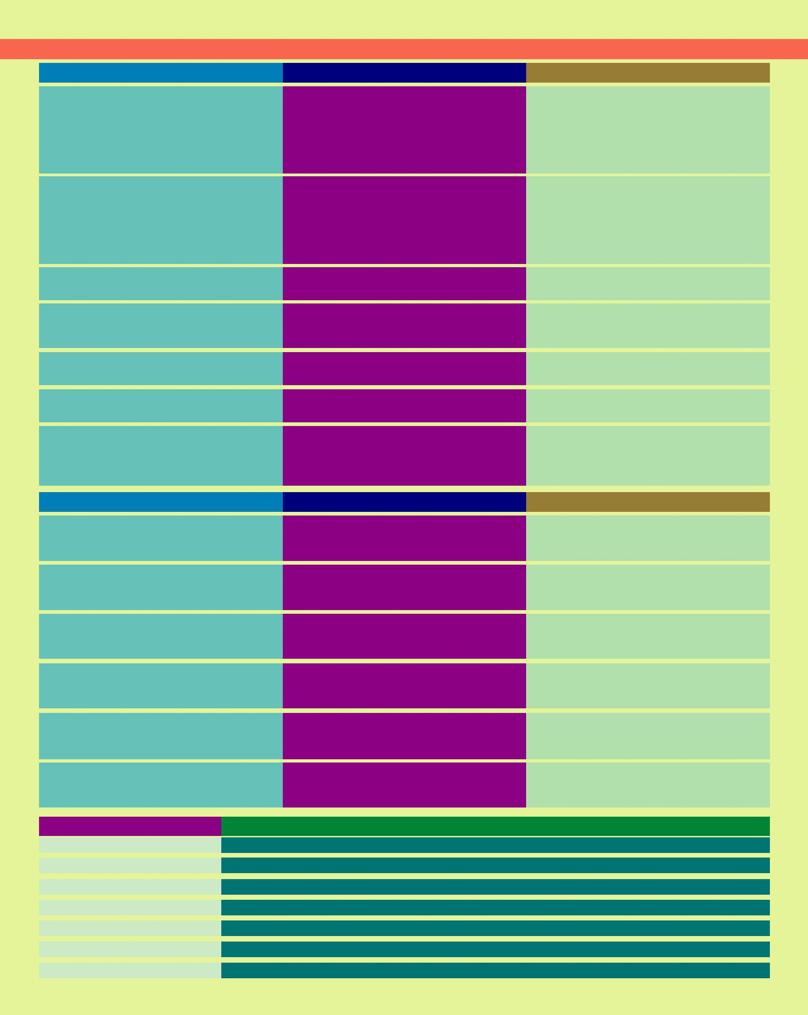

|  |  |  |
| --- | --- | --- |
| Sectional Presidents | Sectional Secretaries |  |
|  | Prof. R.L.N Sai Prasad |  |
| Prof. T. Amarnath | Professor of Physics, NITW |  |
| Prof. P. Malla Reddy |  |
| School of Mathematics & Statistics |  |
| Professor of Mathematics, KUC |  |
| University of Hyderabad, Hyderabad |  |
| Prof. D. Srinivasacharya |  |
|  |  |
|  | Professor of Mathematics, NITW |  |
|  | Prof. M. Sydulu |  |
|  | Professor of Electrical Engg., NITW |  |
| Sri. R. N. Jayaraj | Prof. T.D. Gunneswara Rao |  |
| Former Chief Executive Nuclear Fuel Complex, Hyderabad | Professor of Civil Engineering, NITW |  |
|  | Prof. K. Anand Kishore |  |
|  | Professor of Chemical Engg., NITW |  |
| Dr. R. B. N. Prasad | Prof. Ch. Sanjeeva Reddy |  |
| Former Chief Scientist, IICT, Hyderabad | Professor of Chemistry (Retd), KUC |  |
| Prof. P. Appa Rao | Prof. M. Singaracharya |  |
| Vice-Chancellor | Professor of Botany (Retd), KUC |  |
| University of Hyderabad, Hyderabad |  |  |
| Prof. Chandrakant Kokate | Prof. G. Achaiah |  |
| Former Vice-Chancellor, KUC | Professor of Pharmacy & Director, IQAC, KUC |  |
| Dr. B. G. Sidharth | Prof. K.V. Jayakumar |  |
| Director, B.M. Birla Science Centre, Hyderabad | Professor of Civil Engineering, NITW |  |
| Dr. Ch. Mohan Rao | Prof. L. Krishnanand |  |
| Former Director, CCMB, Hyderabad | Professor of Mechanical Engineering, NITW |  |
|  | Dr. M. Heeralal |  |
|  | Department of Civil Engineering, NITW |  |

|  |  |  |  |
| --- | --- | --- | --- |
| Special Theme Sessions | Sectional Presidents | Sectional Secretaries |  |
| Smart Cities | Prof. CSRK Prasad | Dr. Venkaiah Chowdary, NITW |  |
| Professor of Civil Engineering, NITW | Dr. P. Srinivasa Rao, NITW |  |
|  |  |
|  |  | Dr. Asit Kumar Khanra, NITW |  |
| Renewable Energy Sources | Prof. P. Anand Raj | Dr. S. Srinath, NITW |  |
| Professor of Civil Engineering, NITW | Dr. A. Veeresh Babu, NITW |  |
|  |  |
|  |  | Dr. G. Raghavendra, NITW |  |
|  | Prof. D.V.L.N Somayajulu | Prof. T. Kishore Kumar, NITW |  |
| Information & Communication Technology | | Dr. S. Ravichandra, NITW |  |
|  | Chair, E&ICT Academy, NITW |  |
|  |  | Dr. Ms. V. Venkatamani, NITW |  |
| Science in the Service of Society | Prof. A. Ramachandraiah | Prof. D. Dinakar, NITW |  |
| Professor of Chemistry, NITW | Dr. Ms. K. Madhavi, NITW |  |
|  |  |
|  |  | Dr. B. Srinivas, NITW |  |
| Women Scientists Meet | Dr. Ms. K. Padma | Dr. Ms. H. P. Rani, NITW |  |
| School of Management, NITW | Dr. Ms. G. Shamitha, KUC |  |
|  |  |
|  |  | Dr. Ms. S. Jyothi, KUC |  |
| Science Teachers Meet | Prof. D.V.S.S Siva Sarma | Dr. P. V. Rao, NITW |  |
| Professor of EEE, NITW | Dr. Prakash Saudagar, NITW |  |
|  |  |
|  |  | Dr. B. Rama Raju, NITW |  |
| Other Activities | Coordinators |  |  |
| Distinguished Lectures | Prof. Y. Pydisetty, Dean, Academic, NITW |  |  |
| Panel Discussion | Prof. LRG Reddy, Dean, SW, NITW |  |  |
| Young Scientists Meet | Prof. G. Rajesh Kumar, Dean, R & C, NITW |  |  |
| Poster Session | Dr. M. Joseph Davidson, NITW, Dr. D. Kasinath, NITW, Dr. K. Hari Prasad, NITW, | |  |
| S &T Expo | Dr. A. Benerji Babu, NITW, Dr. Ms. J. Pranitha, NITW, Dr. B. Divakar, NITW | |  |
| Web Coordination | Dr. B. Lakshmi, NITW, Dr. Rashmi Ranjan Rout, NITW, Dr. T. Ramakrishnudu, NITW | |  |
| Press & Publicity | Dr. K. Kiran Kumar, PRO, NITW, Dr. V. Hari Kumar, NITW |  |  |

**Telangana State Science Congress - 2018**

The TSSC-2018 invites Abstracts of innovative and quality research papers from Engineers, Scientists, Industrialists, Technocrats etc., along with articles of popular science to promote scientific temper.

**Submission of Abstracts:**

Abstracts of Scientific/Technical papers not exceeding 500 words are to be submitted online **(http://cms.nitw.ac.in/conference/tssc2018/)** on or before 15th November, 2018. Please indicate the theme of the session on the top right of the Abstract page to be considered for review.

**Registration Fee:**

|  |  |  |  |
| --- | --- | --- | --- |
| Category | On or before 30-11-2018 | After 30-11-2018 |  |
| Students and Research Scholars | Rs. 1,000/- | 1,200/- |  |
|  |  | 2,500/- |  |
| University / College Teachers | Rs. 2,000/- |  |
|  |  | 3,500/- |  |
| Scientists from National / R & D Labs | Rs. 3,000/- |  |
|  |  | 6,000/- |  |
| Industry representatives | Rs. 5,000/- |  |
|  |  |  |  |

Registration Fee is to be paid by Demand Draft in favour of **"Telangana State Science Congress - 2018"** payable at SBI, NIT, Warangal Branch, Warangal or through NEFT to SBI bank Account Number: **37984107940** with IFSC code: **SBIN0020149**. **Cash will not be accepted.** Online registration has to be done through the conference portal after fee payment. If the Registration Fee is not paid on or before 30-11-2018, those abstracts will not be included in the conference proceedings. If anybody is interested to attend the Congress without presenting a paper, he/she is also permitted to register by paying the above mentioned Registration Fee.

**Participation & Registration:**

All the delegates who wish to participate in Telangana State Science Congress-2018 must register. As this is a platform where people from several scientific/technical back ground will be participating, the participants are encouraged to register well within the deadlines.

**Accommodation:**

Limited accommodation is available in the NIT Guest House, Visitors Block and Students Hostels. There are several hotels close to NIT campus, the details of which are available on the conference website.

Contact for accommodation: Prof. N. Narasaiah, Jt. Secretary, TSSC-2018, E-mail: nn@nitw.ac.in, Phone: 08332969384

**Sponsorship:**

Sponsorship is requested from Industries, Government Organizations and Private Organizations to promote the TSSC-2018

|  |  |  |
| --- | --- | --- |
| Category | Tariff (Rs.) | Benefits |
| Conference Sponsor | 2,00,000/- | One Full page multi-colour advertisement in the Souvenir and Five delegates free plus one complementary stall |
| Lunch/Dinner/Reg. Kit | 1,00,000/- | One Full page multi-colour advertisement in the Souvenir and Two delegates free |
| Event Sponsor | 50,000/- | One Full page Black and White advertisement in the Souvenir |
| High Tea | 25,000/- | Half page Black and White advertisement in the Souvenir |

**S & T Exhibition Tariff:**

Equipment manufacturers, suppliers, service providers, Educational Institutions, Publishers and Industries can participate in the exhibition. Standard stall space (6' X 9') along with power supply are provided for display by paying Rs. 50,000/- per each stall for 3 days. Two free registrations will be allowed for each exhibitor. For any specific facility/requirement, the exhibitors may contact the Organizing Secretary well in advance.

|  |  |  |  |  |  |  |  |  |  |
| --- | --- | --- | --- | --- | --- | --- | --- | --- | --- |
|  |  | Advertisement Tariff for the | | Souvenir | | |  |  |  |
|  |  | Back Page Cover (Multi-Colour) | : |  | Rs. 50, 000/- | |  |  |  |
|  |  | Front Inner Page (Multi-Colour) | : |  | Rs. 40, 000/- | |  |  |  |
|  |  | Back Inner Page (Multi-Colour) | : |  | Rs. 30, 000/- | |  |  |  |
|  |  | Inner Page (Multi-Colour) | : |  | Rs. 20, 000/- | |  |  |  |
|  |  | Inner Half Page (Multi-Colour) | : |  | Rs. 10, 000/- | |  |  |  |
|  |  |  |  |  |  |  |  |  |  |
| *For Correspondence and e-Contact* | | |  |  | *For Direct Presonal Contact / Visit* | | | |  |
| **Prof. K. Laxma Reddy** | | |  |  | **Prof. K. Laxma Reddy or** | | | |  |
| Organizing Secretary, TSSC-2018 | | |  |  |  |
|  |  | The Staff at the Camp Office at | | | |  |
| Departmentof Chemistry | | |  |  |  |
|  |  | Dean, IRAA Office, Ground Floor, SOM Building | | | |  |
| NIT, Warangal-506 004 | | |  |  |  |
|  |  | E mail: tssc-2018@nitw.ac.in | | | |  |
| E mail: tssc-2018@nitw.ac.in | | |  |  |  |
|  |  | Phone (O): 0870-246 2008 | | | |  |
| Phone (O): 0870 246 2008 | | |  |  |  |
| Mobile: 08332969493, 08332969439 | | |  |  | Mobile: 08332969493, 08332969439 | | | |  |
|  |  | IMPORTANT DEADLINES | | | | | | |  |
|  | Online Abstract submission, on or before | | | |  | 15th November, 2018 | |  |  |
|  | Communication of acceptance of Abstracts by | | | |  | 20th November, 2018 | |  |  |
|  | Payment of early Registration fee, on or before | | | |  | 30th November, 2018 | |  |  |

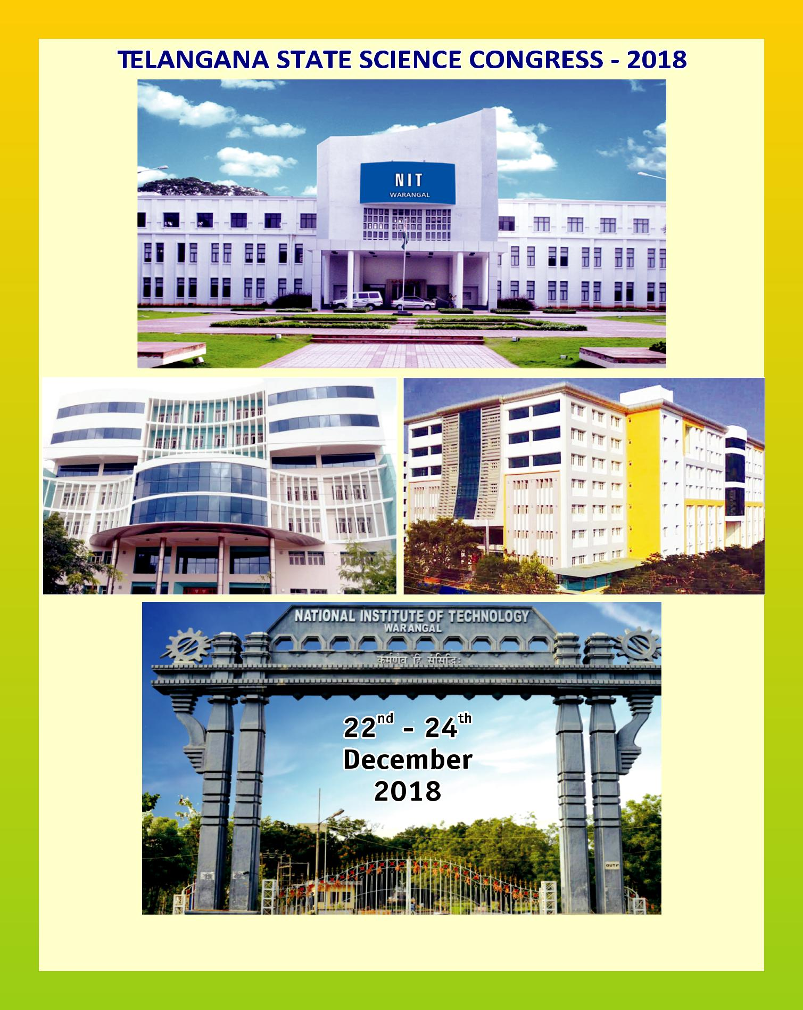

**TELANGANA ACADEMY OF SCIENCES**

O.U. Qtr. No. L-68, Besides International Hostel, Tarnaka, Hyderabad-500 017

Ph: 040-2700 8029, E-mail: tsas2015@gmail.com, tsas2015@yahoo.com Website: www.tasc.org.in

|  |
| --- |
| deepa graphics, wgl-9849235297 |